Capstone Project

Project Title: Tairawhiti Rising

Introduction
*Kia ora. My name is Lavinia and I am introducing you to my Capstone Project, a social media application called Tairawhiti Rising.

Go through the content….

Purpose
*Tairawhiti Rising provides a platform for users to access support or offer support to others who may be going through similar experiences.

It is an online community supporting each other to strengthen family and future generations through shared learnings and community voice.

The insights gained by user voice and experiences can be used to inform improvements in social service design.

Problem / Solution

What is the problem or the opportunity that the project is investigating? Why is this problem valuable to address?
Individuals in Tairawhiti are finding it harder to access the support that they need from agencies and service providers in the community, with unmet needs increasing and contributing to negative outcomes for families.

Agencies rarely understand the true needs of the people they serve, nor do they document what matters to them. Current social service measurement focuses on administrative outputs - attendance, task completion, and program delivery - rather than the quality of user experiences. Existing survey-based methods capture limited feedback, often failing to reveal why a service succeeds or falls short.

Social service agencies struggle to capture the authentic voice of users. Without accurate insight into user experience, service design does not address what matters to users and when issues arise services are not improved effectively. Moreover, system changes are often slow, adding to staff workload, implemented without proper testing, and can produce unintended consequences, creating additional problems.

Tairawhiti Rising aims to improve access to knowledge about services in Tairawhiti - where and how to access them. Tairawhiti Rising increases connection across community, enabling community to support where they can and offer insights in to processes new to them.

Increasing the efficacy of individuals ensures that Tairawhiti rises, without waiting for a system to act, or relying on a system that cannot provide for the range of needs presenting. By improving access to information and strengthening understanding of user experience, Tairawhiti Rising creates an opportunity for service design to reflect what matters to users, to understand where there are significant gaps in services, and for services to be improved effectively.

Ultimately what Tairawhiti Rising does is strengthen community capability and supports better outcomes for families.

Current State – Desired State

What is the current state (e.g. unsatisfied users, lost revenue)?
*Social services are under pressure to meet government-mandated targets, which may not align with the actual needs of users.

For example, courts order individuals to attend anger management programs funded through non-government organizations. These programs are delivered and reported according to contract requirements, not necessarily what users need. Many participants do not want or need the mandated program; their needs often require other forms of support.

Services are delivered according to system capabilities and funding, not individual needs
This creates a self-perpetuating cycle: services appear necessary and well-utilized, while real user needs remain unmet.

In a report published by the Social Investment Agency, it was noted that government invests significant amounts of funds on commissioned services, (estimated to be between $6 – 8 billion per annum in 2021) on top of significant service provision provided directly from agencies. However, in many cases outcomes have gone backwards.
Providers working with these individuals and whānau are constrained by output-focused contracts that count the wrong things. The current approach is not focused on outcomes and does not use data and evidence to improve services to prevent escalation of need.

What is the desired state?
*The project aims to:

- Capture authentic user experiences and perspectives.
  - e.g. Chat forum

- Enable individuals to learn from one another and reduce reliance solely on the system.
  - e.g. Where to go for specific services, how to access products, how to complete forms, how to work through processes such as emergency housing.

- User feedback informs system design, service improvement, and program delivery
  - What are the needs, what type of needs, how often – highest demand, most complex, administrative, advocacy, gaps in service delivery.

- Translate experiences into practical guidelines for future users and service providers
  - e.g. Guidelines and templates based on user feedback and real process.

Has this problem been addressed by other projects? What were the outcomes?
*Manaaki Tairawhiti attempted to influence change in government agencies using system improvement coaches, with some success until COVID-19 disrupted operations. Since then, multiple projects have tried to collect whānau voice to influence government services. The main mechanism for capturing whanau voice or user feedback ended in June 2025 and that was reliant on navigators employed within organisations collecting user voice.

Key learnings from these projects:

What worked: User voice clearly highlights gaps and priorities, flexible frontline approaches (“whatever it takes”) can achieve real change.

What didn’t work: Sustained impact requires leadership by-in, funding, and contract alignment. Disconnects between Central and local government layers can block meaningful progress.

These insights show the importance of a structured, sustainable approach to capturing user experience—one that can influence system design and service delivery effectively.

Tairawhiti Rising aims to remove the need for third party collection of user voice and experience and gives individuals the opportunity!! to share their own voice and the impact their experience has on their lives.

Industry/ domain

What is the industry/ domain?
*The project focuses on the social service sector, including government agencies, non-government organisations (NGO’s), and community support services.

What is the current state of this industry? (e.g. challenges from startups)
- The mechanisms to capture user voice is limited and has been slow.
- While there has been proven success in capturing user voice, there is no consistent user voice captured across the sector and user-informed service improvements has been limited.
- Social services operate largely through government contracting and commissioning, which drives priorities, reporting requirements, and what services are delivered.
- The sector faces pressures such as limited funding, high demand, and workforce constraints, which impact responsiveness to user needs.

*What is the overall industry value-chain?
- Funding / Commissioning
Government agencies fund programs based on policy priorities.
- Program Design & Delivery
NGOs and service providers design and deliver programs to meet contract requirements.
- User Engagement
Clients access services; feedback is inconsistently captured.
- Reporting & Evaluation
Services report outputs (attendance, compliance) rather than outcomes (user satisfaction, wellbeing).
- Policy & Program Review
Government reviews contracts and funding decisions, often without real-time or in-depth user feedback

*What are the key concepts in the industry?
- Whānau voice / user experience
Capturing authentic feedback from service users to inform service design.
- Commissioning / contracting
Government-funded service agreements that define outputs, metrics, and reporting.
- Service quality vs. quantity
Meeting real user needs versus administrative measures.
- Outcomes-based evaluation
Measuring the impact of services on wellbeing, not just attendance or compliance.
- Co-design / participatory design
Involving users in designing services to better meet their needs.

There is a lack of authentic consistent user experience captured by agencies. Tairawhiti Rising addresses this by creating a platform that captures user insights, enables sharing of real-world experiences and can inform service design and delivery, responding to real needs, for real outcomes.

*Is the project relevant to other industries?
The approach of capturing user voice to inform service improvements is relevant to any sector where services are delivered for a customer.

Benefits of applying this approach include:
- Resources are focused on what is truly needed.
- Increased efficiency and reduced waste.
- Potential for community or organizational growth.
- Better staff morale and engagement.
- Industries like healthcare, education, local government services, and even commercial service providers can learn from these practices to improve responsiveness and user satisfaction.

Stakeholders

Who are the stakeholders?
- Service Users (Individuals, Whānau): Those seeking support from social services, who will use the platform to share experiences and access information.
- Government Agencies: Policymakers and funders interested in improving service outcomes and accountability.
- NGOs and Service Providers: Frontline organizations delivering services and using insights to improve program delivery.
- Community Groups and Advocates: Supporting user engagement and amplifying community voices.
- Tairawhiti Rising Project Team: Developers and managers maintaining the platform and driving service improvements.

Why do they care about this software?
- Service users want accessible, relevant support and a way to have their voices heard.
- Government agencies seek better data to guide policy and improve effectiveness.
- NGOs need actionable feedback to tailor services and meet user needs.
- Community groups want to empower local voices and build stronger connections.
- The project team aims to enable authentic, consistent user feedback to improve services sustainably.

What are the stakeholders’ expectations?
- A user-friendly, secure platform for sharing experiences and accessing information.
- Accurate, meaningful insights that lead to real service improvements.
- Transparent communication and responsiveness to user feedback.
- Support for community empowerment and collaboration across agencies.
- Data that informs policy and resource allocation effectively.

Product Description
Tairawhiti Rising consists of three main components:
Landing Page
- Welcome Page: Providing introduction information
- Content Sidebar: Displays relevant content, resources, or announcements.
- Access buttons to both the Log-in or Sign-up pages. Registered users can access the chat forum.
- Sign-Up Page: For new users to register. This is where the unique user identifier for tracking the user in the database is allocated.
- Log-in Page: Identifies the user and the specific user ID assigned in the Tairawhiti Rising database.

Community Chat
- Users can post queries, give advice, and comment on other posts.

Database
- Stores all user information and posts.
- Ensures data is secure, structured, and retrievable for future analysis.

Dashboard (future scope)
- Visualizes aggregated user data and activity trends.
- Provides insights for service providers and administrators.
- May be implemented after initial testing and validation of the chat/forum functionality.

Architecture Diagram
A diagram of the building blocks of the design including users and how they interact with the product.
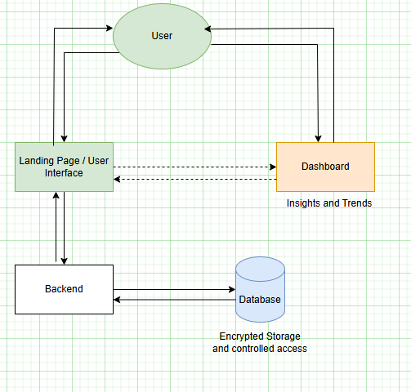

User Stories
# | User Story Title | User Story Description | Priority | Additional Notes
1 | Landing Page | User arrives at the landing page, can sign up or login to access the chat forum and dashboard. | HIGH | Simple navigation, clear purpose and usage instructions.
2 | Creating an account | User can sign up to register, contribute, and receive support. Assigned a unique ID – anonymous BUT unique based on e-mail address. | HIGH | Required:  Username  Email address  Password (*encryption)  Date of birth
3 | Logging in | User can sign in using e-mail and password to access chat forum. | HIGH | Logs user activity by unique id.
4 | Chat Forum Display | User can see the chat forum after login, can post queries and advice or comment on posts. | HIGH | Main interaction area.
5 | Dashboard Display | User can navigate to the dashboard after login. | Low | Optional feature for data visualisation and insights.
6 | Searching for Categories | User can search for keywords or by category for relevant information. | Low | Enhances user navigation.
7 | Making a Post | User can post information or ask questions, including context around their needs. | HIGH | Enables sharing and learning from user experiences.
8 | Making a Comment | User can comment on posts to provide advice or share experiences | HIGH | Encourages interaction and support
9 | Editing / Deleting | User can edit and/or delete their own posts and comments. | HIGH | Provides User control over their content.
10 | Logging feedback | User can submit faults or suggestions with the feedback button. | Low | Supports continuous Improvement.
12 | Logging out | User can log out, stopping access to forum and dashboard. | HIGH | Secures user sessions.

User Flow
High Level diagram of the steps a user may make in interacting with the software.
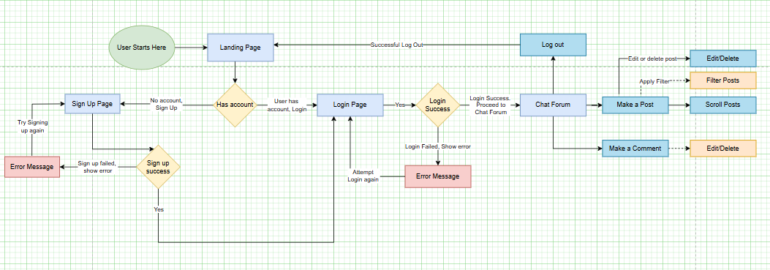

DATABASE Logical Model
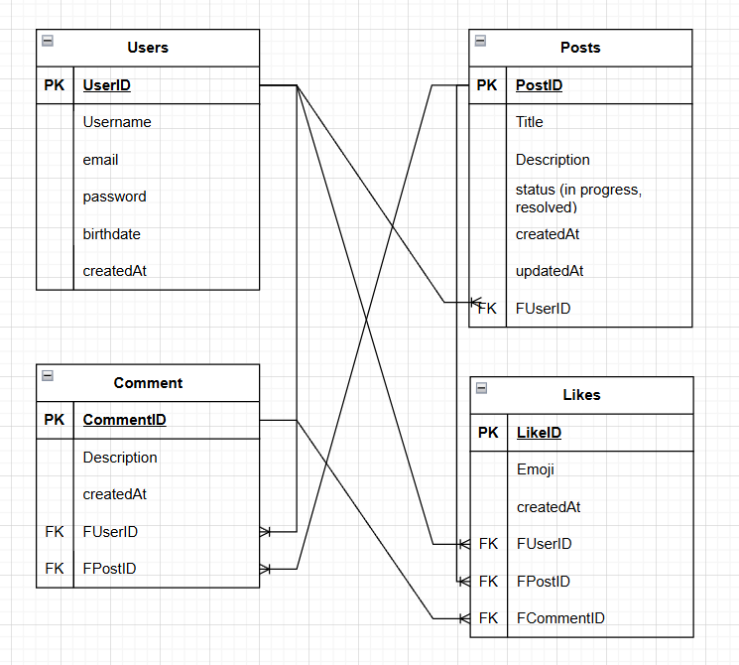

DATABASE Physical Model

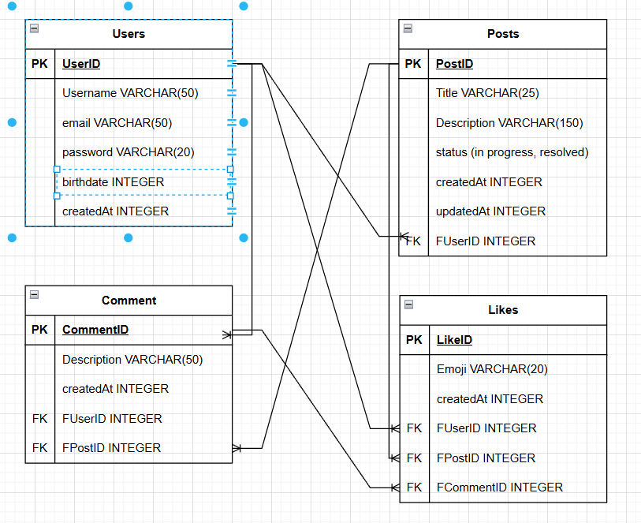

Wireframe Design

Landing Page
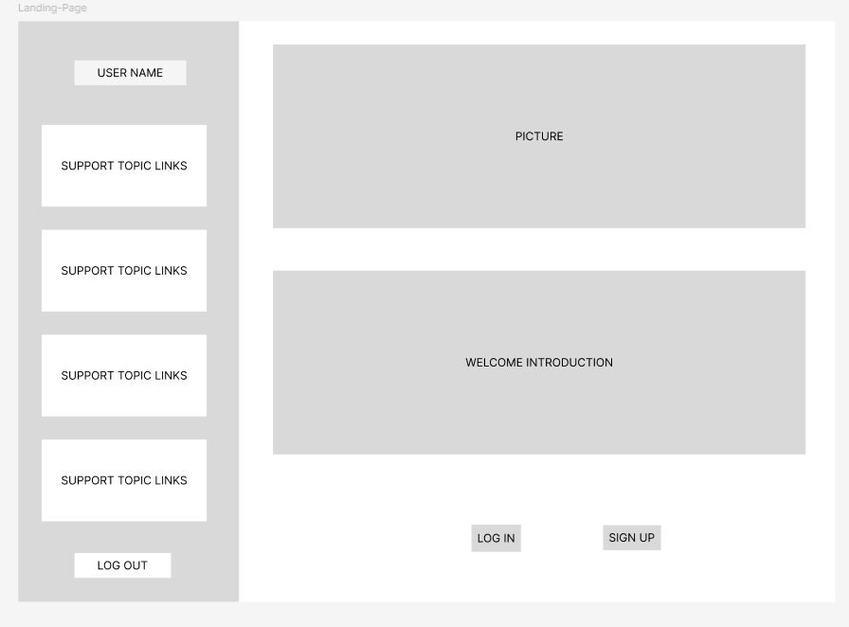

Login Page
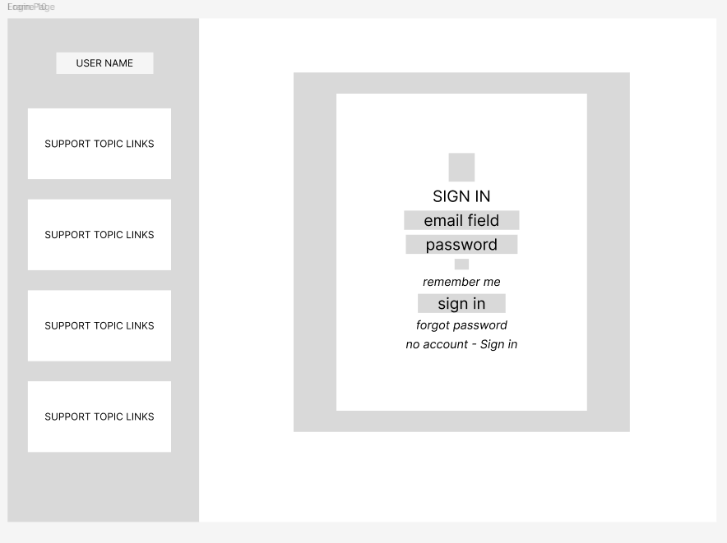

Sign Up Page
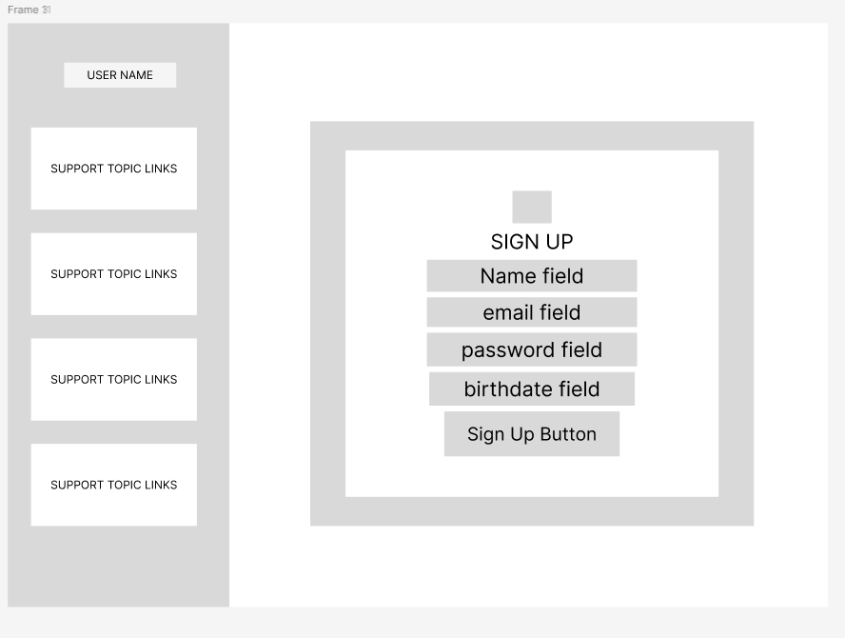

Chat Forum Page
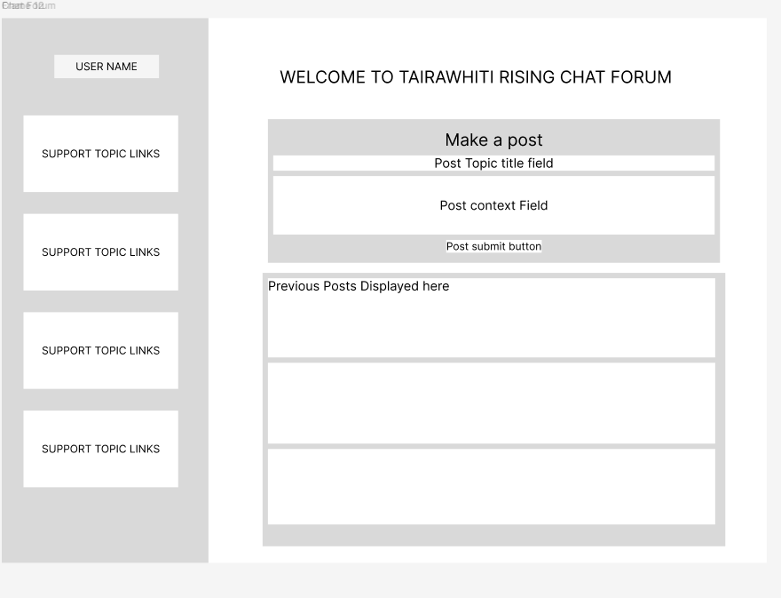

Dashboard Page
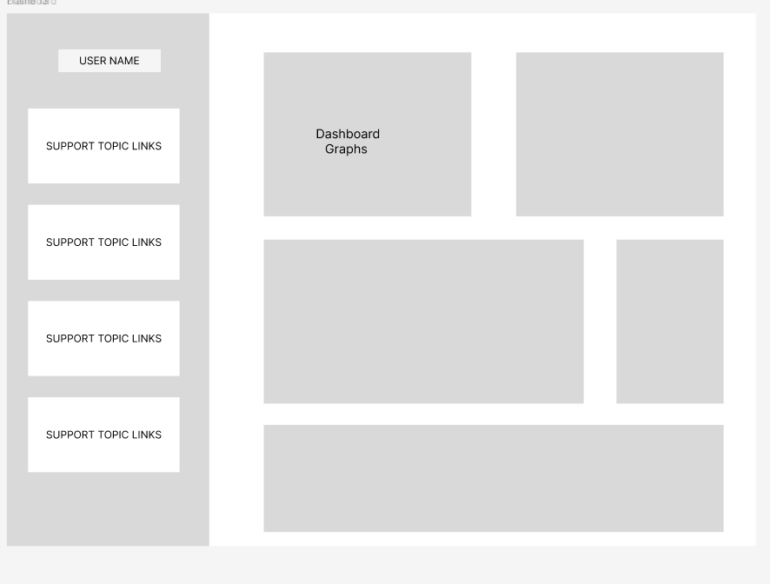

UI Design Concept
Component | Preview | Reasons
Name | Tairawhiti Rising | The area is Tairawhiti. The purpose of the app is for the community to rise and grow. Remove the dependency on the system where possible.
Font | Roboto | Modern, clean and easy to read.
Colour Scheme | Greens, greys, blues | Earthy tones …… of the Tairawhiti landscape
Logo | Infinity Symbol made of people | Symbolises a community standing together and continuously striving to rise up – no man left behind.

Out of Scope

What features are considered out of scope?
- Dashboard functionality / Analytics scheduled for v2
- Personalisation - Avatar/Profile Picture
- Security - secure authentication process - Password hashing, sessions, tokens
- Search filters
  - Based on user trends e.g. high levels of budgeting queries, more information provided about budgeting.
- Feedback functionality
  - Users can submit a feedback form.
  - Feedback stored securely in the system.
  - User sees confirmation message after submission.
- Administrator functions:
  - Admin can delete any post/comment.
  - Actions logged for accountability.

Non-functional Requirements

What are the key security requirements? (e.g. login, storage of personal details, inactivity timeout, data encryption) performance, scalability, reliability, security, useability, availability, maintainability, compatibility
- Storage of personal details – email address and User ID, password, birthdate.
- The User Id will be used for interactions and analytics to maintain anonymity.
- Access to personal data is restricted and controlled.
- Inactivity/timeout / session management – sessions expire automatically after inactivity (30mins) to enhance security.

How many transactions should be enabled at peak time?
Peak transactions - load testing and performance testing will determine maximum users and transaction capacity. 200 requests per minute initially.

How easy to use does the software need to be?
Software should be intuitive and accessible to users with a wide range of technical abilities.

How quickly should the application respond to user requests?
Response Time – The application should respond quickly to user requests to maintain usability and satisfaction.

How reliable must the application be? (e.g. mean time between failures)
- Application must be reliable to maintain user confidence and increase use.
- Due to simple architecture, minimal downtime is expected.
- External Links may fail occasionally, users will be notified and advised that these sites are managed externally.
- It is anticipated that any failures will be picked up quickly (user notification) and managed within a short period of time -relationship with owners of linked sites.

Does the software conform to any technical standards to ease maintainability?
- Backend uses MVC (model view controller structure for separation of concerns).
- Frontend utilises reuseable components (e.g. custom hooks, cards)
- Code separated according to each component to simplify maintenance.
- Designed for scalability and future feature addition.

Project Planning
Key milestones (with dates) to complete the project.

Testing Strategy

What were steps undertaken to achieve product quality?
Design Validation checked using low fi design in Figma, use cases and database logical and physical models. Testing using Thunder client, console.log and testing through ongoing manual testing of the application.

How was each feature of the application tested?
- Database API testing using Thunder client to test CRUD operations for posts comments user registration and login.
- Manual user testing – walked through all user flows to ensure functionality.
- Browser Inspect to check responsivity, work through console errors, check styling.

Landing Page
- User sees clear options to log in or sign up.
- Navigation is intuitive, all buttons clickable.

Create Account
- Users can submit required fields: username, email, password, birthdate.
- Password is stored.
- Unique ID is assigned.

Log In
- Users can log in with correct email/password.
- Error messages are shown if credentials are incorrect.
- User directed to chat forum.

Make Post / Comment
- Users can enter post/comment content.
- Validation ensures content is not empty.
- Submitted content appears in forum immediately.
- Users can edit or delete their own posts/comments.

How did you handle edge cases?
Attempted actions such as:
- Submitting empty posts or comments
- Duplicate registrations
- Editing/deleting posts not belonging to the user
- Used console logs and browser inspect tools to monitor errors and validate handling.

Implementation

What were the considerations for deploying the software?
Maintainability & Scalability:
MVC backend structure
Reusable frontend components
Separation of UI and logic for easy updates
Performance & Reliability:
Initial testing on small user groups to monitor response time
Considerations for future load/performance testing
Deployment Considerations:
Hosting environment (local dev → staging → production)
Version control for safe rollout
Documentation for future developers and administrators
Security & Privacy:
Password encryption
Unique user IDs for anonymity
Minimal personal data storage

End-to-end solution

How well did the software meet its objectives?
Objective Achievement:
- Captures user voice
- Enables knowledge sharing within the community
- Supports service improvement through user feedback
Limitations / Scope for Improvement:
- Dashboard functionality planned for version 2.0
- Optional profile pictures planned for later versions
- Further integration with government systems for automated reporting
- Analytics and Reporting – track post topics and comments – top topics, needs or concerns.
- User Feedback – tracking for improvement
- Additional UI work for clean, simple user interaction, navigation.
- Add a user guide
- Regular Load testing as the community grows.

References

Where is the code used in the project? (link to GitHub)
https://github.com/lavip120-a11y/CapStoneProject2026.git

What are the resources used in the project? (libraries, APIs, databases, tools, etc)
- Git – repository for code
- Visual Studio Code – terminal
- ThunderClient
- React
- Material UI – templates and components
- CSS
- Sequelise
- Nodejs
- "cors": "^2.8.6",
- "dotenv": "^17.3.1",
- "express": "^5.2.1",
- "mysql2": "^3.20.0",
- "nodemon": "^3.1.14",
- "sequelize": "^6.37.8"
- "@emotion/react": "^11.14.0",
- "@emotion/styled": "^11.14.1",
- "@mui/icons-material": "^7.3.9",
- "@mui/material": "^7.3.9",
- "axios": "^1.13.6",
- "react": "^19.2.4",
- "react-dom": "^19.2.4",
- "react-router-dom": "^7.13.1"
- "@eslint/js": "^9.39.4",
- "@types/react": "^19.2.14",
- "@types/react-dom": "^19.2.3",
- "@vitejs/plugin-react": "^6.0.0",
- "eslint": "^9.39.4",
- "eslint-plugin-react-hooks": "^7.0.1",
- "eslint-plugin-react-refresh": "^0.5.2",
- "globals": "^17.4.0",
- "vite": "^8.0.0"
- Manaaki Tairawhiti Website
- Social Investment Agency Report

